**GREENLAND: A SECURE LAND REGISTRATION SCHEME FOR BLOCKCHAIN AND AI-ENABLED AGRICULTURE INDUSTRY**

### ****ABSTRACT****

The project "Greenland: A Secure Land Registration Scheme for Blockchain and AI-Enabled Agriculture Industry 5.0" introduces a secure and intelligent framework for land transaction management using Blockchain and Artificial Intelligence. Traditional land registration systems rely on centralized databases that are prone to tampering and lack transparency. To overcome these limitations, the proposed system leverages Ethereum-based Blockchain technology for decentralized, tamper-proof data storage, and IPFS (InterPlanetary File System) for secure file handling. Smart contracts, developed in Solidity, manage land transaction details, ensuring trust and immutability. Additionally, AI algorithms are integrated to detect fraudulent land transactions from raw Blockchain data. Multiple machine learning models—Logistic Regression, Random Forest, SVM, XGBoost, and LightGBM—were trained and evaluated on an Ethereum fraud detection dataset, with LightGBM achieving the highest accuracy of 99.35%. The system includes a web-based interface for buyers and sellers to interact securely, make land requests, and view transaction statuses based on AI predictions. This comprehensive solution enhances transparency, security, and fraud detection in the agriculture sector, aligning with the goals of Industry 5.0.

### ****EXISTING SYSTEM****

The traditional land registration system relies heavily on centralized servers, which store and manage all land transaction data. These systems are vulnerable to manipulation and tampering by administrators or unauthorized users, as they lack transparency and auditability. Centralized storage makes it difficult to trace or verify the authenticity of historical transactions, leading to disputes, fraudulent activities, and loss of trust in the land registry process. Moreover, existing systems do not utilize intelligent mechanisms to detect fraudulent transactions or irregular patterns within the land registration process.

### ****PROPOSED SYSTEM****

The proposed Greenland system addresses these limitations by implementing a decentralized and secure land registration scheme using Blockchain and AI technologies. It uses Ethereum Blockchain and smart contracts written in Solidity to ensure tamper-proof, transparent, and immutable storage of land transaction data. All raw data is securely stored in the InterPlanetary File System (IPFS), and its hash is recorded on the Blockchain for reliable verification. Artificial Intelligence algorithms such as LightGBM, XGBoost, SVM, and Random Forest are used to analyze transaction patterns and detect fraudulent activities with high accuracy. A user-friendly web interface is provided for buyers and sellers to register, initiate, and approve land transactions based on AI predictions. This system enhances security, transparency, and fraud detection, aligning with the vision of Agriculture Industry 5.0.

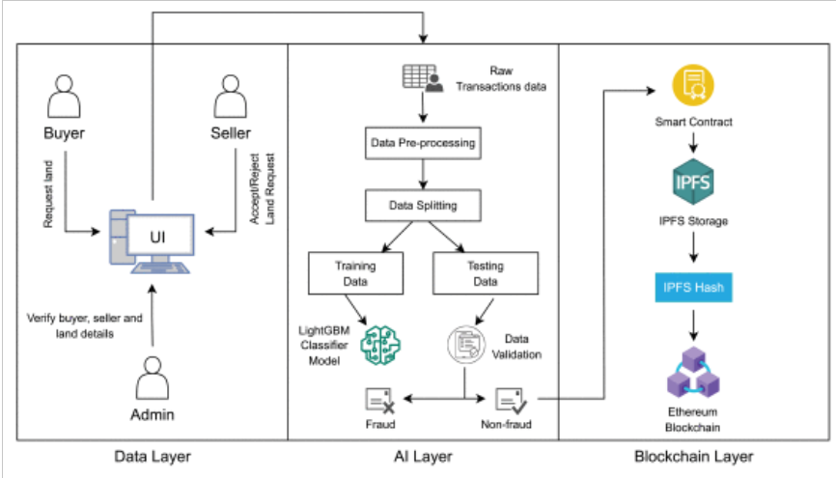

**SYSTEM REQUIREMENTS:**

**HARDWARE REQUIREMENTS:**

* Hard Disk  :   40 GB.
* Ram    :   512 MB.

**SOFTWARE REQUIREMENTS:**

* Operating system   : Windows 7
* Coding Language  : pythoncksbcjiagdjbka